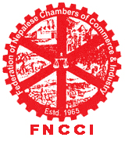


Are you an Entrepreneur or logistics professionals keen on improving your organization competitive advantage or fresh graduate looking for job opportunity?

Federation of Nepalese Chambers of Commerce & Industry (FNCCI) Presents

Training on
Managing International Logistic & Negotiating
Based on
MLS- International Purchasing and Supply Chain Management
Developed by International Trade Centre
UNCTAD/WTO

Training Duration: 3 Days (13-15 Dec 07)
Time: 9:30 – 16:30
Venue: FNCCI - HRD Hall, Teku
Fees: Rs. 1000 /- inclusive handouts and lunch

Register at: FNCCI-HRDC; Teku, Kathmandu
Tel:4262218, 4262061

OR
Download enrollment form from our URL: http://www.fncci.org/events/2007_12_1315.html and send it via mail at : hrdc@fncci.org

